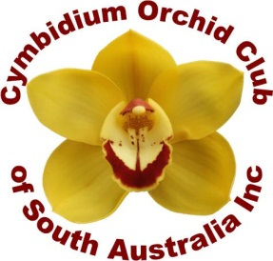
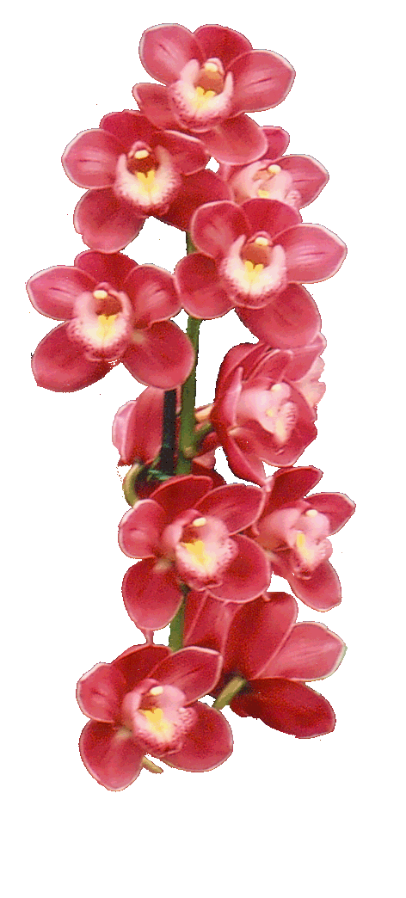
Cymbidium Orchid Club of SA Inc
http://www.cymorchidssa.com.au
11Jeanes Ave
Glenelg North SA 5045
042053951

MEMBERSHIP APPLICATION and RENEWAL Form

Subscription Rate $40 per year Which Includes 10 editions of the Cymbidium News and club name badge.

Please indicate NEW MEMBER RENEWAL

Mr./ Mrs./Ms. (please circle) Surname………………………………………………………

Given Name/s……………………………………………………………………………….

Preferred Name…………………………………………………………………………….

Address………………………………………………………………………………………

Suburb……………………………………………………………………………………….

Post Code ……………………………. State…………………………………………….

Telephone…………………………………. Mobile……………………………………….

Email……………………………………………………………………………………….

Show Number if applicable………………………………………………………………

Other Club Membership…………………………………………………………………

Payments can be made by Cash/Direct Debit or Credit Card

Direct Credit/EFT Bank SA BSB 105-108 Acct No 022900640

If paying by direct debt please put your name in on your payment and contact the treasurer Christine on 08 85363948 and tell her of your payment

